_________________________________________________________________

Seminar Type, e.g. Business
Analytics

– Term, e.g. Summer Term 2018 –

Seminar Paper Title

Submitted by:
Your Name
Student-ID:
1234567
Advisor:
Name of your advisor

Content
1. Introduction 3
2. Formatting 3
2.1 Cover 3
2.2 Headings and TOC 3
2.3 Document 4
2.4 Figures and Tables 4
3. Citations 5
4. Conclusion 5
5. References 6
6. Appendix 7

Abstract
Abstract here

Introduction
This is the template for the seminar term paper at the Chair for Information Systems Research in the winter semester 2018/2019. If you want to professionalize your work and increase efficiency, we strongly encourage you to search for (Internet) resources on automatic references.
To achieve a good grade, it is highly recommended to include both a nicely-written introduction as well as a focused conclusion. The introduction should, in particular, state relevance and importance of your work. For instance, when you are assigned to the topic “Linear regression” you should answer the questions: Why does one need linear regressions? Where does one need linear regressions? Which problems require a linear regression for solving? You might want to finish your introduction with a brief outline describing the structure of your paper.
For users of LaTeX, a special TeX template is available.

Formatting
This section contains the formatting suggestions for your seminar paper. For the entire document except the references section use 1.5 line spacing. For the entire document except the cover sheet use Arial. The document should be an A4-format with a 2.5 cm margin on the left, right, and at the top, and a 2 cm margin at the bottom.

Cover
Place the Uni Freiburg and Information Systems logos in the top right corner of your paper. Use a serif-less font like Calibri or Arial. The seminar title and the title of your topic should be in a 20 pt. bold font (or use the Cover H1 style in this template). The text “Seminar Winter Semester …” and “Seminar Paper” should be in a 16 pt., bold, uppercase font and framed by a dash on each side (Cover H2 style). The text including your name, advisors, and student ID should be 14 pt. bold font (Cover text style).

Headings and TOC
First-level headings should be 14 pt. bold font (Überschrift 1 / Heading 1 style), second-level headings should be 14 pt. bold font, as well (Überschrift 2 / Heading 2 style), and third-level headings should be 12 pt. bold font (Überschrift 3 / Heading 3 style). Do not use more than three different levels of headings. Your table of contents should list all sections, including the references section and appendices, but not the table of contents itself. If you are unable to use the Word table of contents, use a table like in this document (TOC style). The heading “Content” should be like the first-level headings, but without numbering.
You might find advice on how to use automatically-numbered captions in Word at http://office.microsoft.com/en-us/word-help/add-captions-in-word-HA102227021.aspx or http://www.addictivetips.com/microsoft-office/insert-captions-cross-references-in-word-2010/ respectively.

Document
The basic text in your document should be 11 pt. Arial and fully justified (Standard style). In case you add code snippets, please use a monospace font such as Courier New. Be aware that you links to websites should have no underline and are also typed in black color – i.e. http://www.sample-website.com.

Figures and Tables
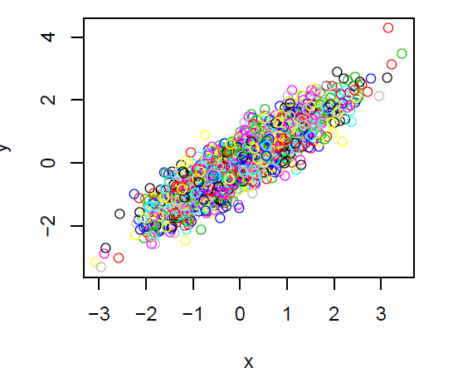
Figures and tables should be centered and numbered (Figure 1, Table 1, …) with the captions being centered, as well. Use 11 pt. bold font for the captions.
Figure 1: Sample caption.
Only meaningful figures and tables should be included in your document body, the rest can be appended. We strongly encourage you to check out instructions on automatic captions and references. Please be aware that captions accompanying must end with a punctuation mark.

The standard guideline for figures and tables is to reference the object (compare Table 1) first and then insert this object after the according paragraph!
 | Column 1 | Column 2
Row 1
Table 1. Meaningful description of this table and a sentence that ends with a punctuation mark.

Citations
Use the MISQ references format for all citations in your paper. Do not use footnotes for citations. The MISQ references format can be accessed at http://www.misq.org/manuscript-guidelines. Here are some sample sentences:
(Davidoff, 2006) argue that simply the provision of information on energy consumption can already induce behavioral changes. This paradigm translates research from ubiquitous and context-aware computing to provide a more comfortable living environment (Davidoff et al. 2006). Hence, it transcends the sole function of energy management, which nevertheless remains an essential part (e.g. Han and Lim 2010; Jahn et al. 2010).
Refer to section 5 in this document for the sample references associated with these sample sentences. In the references section use single line spacing (Reference style). Please check that all references are sorted alphabetically. You are strongly encouraged to use professional software for managing your references. You might try recent versions of Word; however, consider sophisticated solutions such as Citavi (http://www.citavi.com), where free licenses are available through the University.

Conclusion
Please adhere to these formatting suggestions as closely as possible. This template was created for Word 2010 and should work for Word 2007, as well. The .doc-version should work with earlier Word versions.
The way you write strongly affects how your text is interpreted. Therefore, we recommend you to read “The Science of Writing” by George Gopen (http://www.docstyles.com/library/ascience.pdf) carefully and to follow all suggestions closely.

References
Davidoff, S., Lee, M., Yiu, C., Zimmermann, J., Dey, A. 2006. “Principles of Smart Home Control,” in UbiComp 2006: Ubiquitous Computing (Lecture Notes in Computer Science), P. Dourish and A. Friday (eds.), Berlin / Heidelberg: Springer, pp. 19-34.
Han, D.-M., and Lim, J.-H. 2010. “Design and implementation of smart home energy management systems based on zigbee,” IEEE Transactions on Consumer Electronics (56:3), pp. 1417-1425.
Jahn, M., Jentsch, M., Prause, C. R., Pramudianto, F., Al-Akkad, A., and Reiners, R. “The Energy Aware Smart Home,” in 5th International Conference on Future Information Technology (FutureTech), Busan, South Korea, pp. 1-8.
Ueno, T., Sano, F., Saeki, O., and Tsuji, K. 2006. “Effectiveness of an energy-consumption information system on energy savings in residential houses based on monitored data,” Applied Energy (83:2), pp. 166-183.

Appendix

